**JAVAIRIA REHMAN**

**19P-0020**

**BS(CS) 19-5A**

**“computer networks ”**

**Lab task 6**

**Configuration of mail server on cisco packet**

**Step1** make scenario and label IP address.

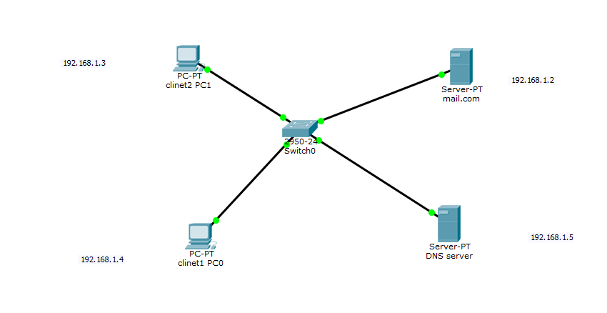

**Step 2** assign IP address and DNS IP to all computers ,dns and mail server static

PC

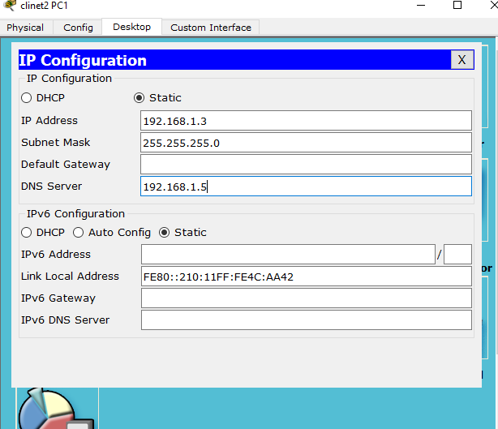

MAIL

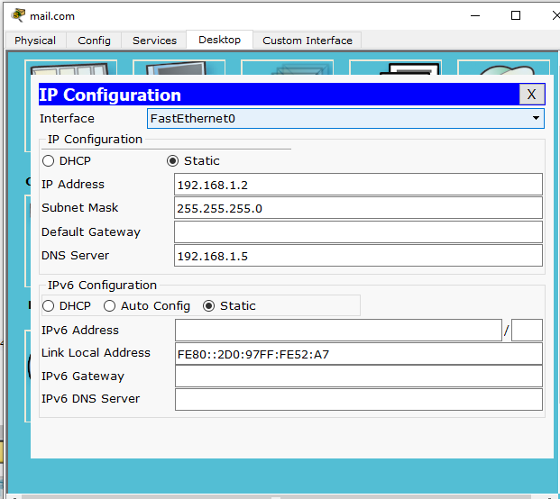

DNS

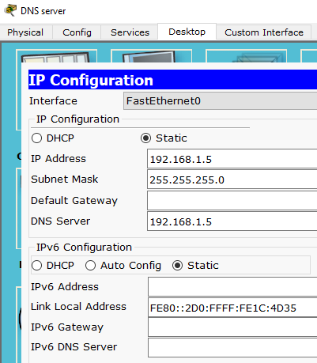

**Step 3**

1. Go to pc
2. Go to desktop
3. Open email
4. Assign email address and password

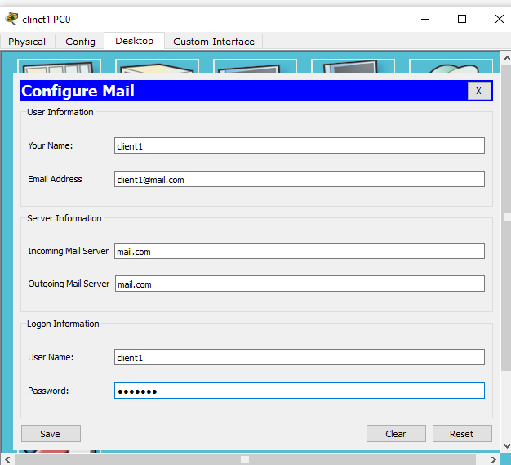

**Step 4**

1. go to mail server
2. go to services
3. add both email addresses

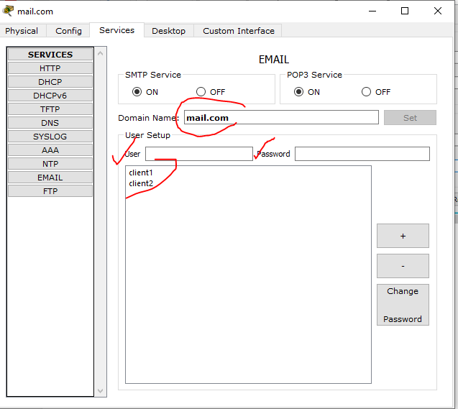

**Step 5**

Configure DNS services on service

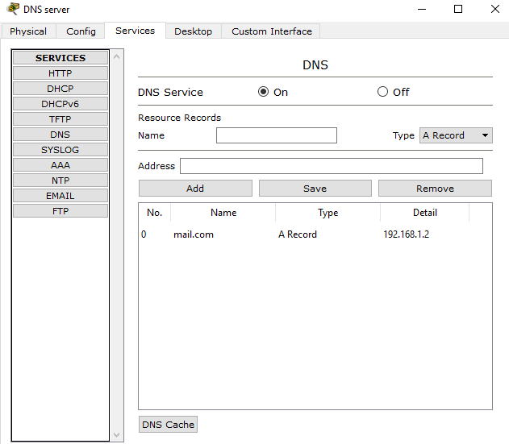

**Step 6** packet sending

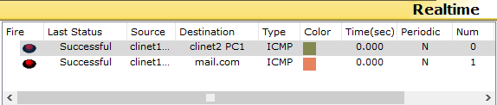

**Step 7** send email pc email compose write email

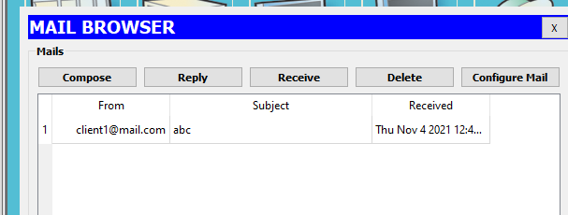

**ftp:**

**step 1** scenario

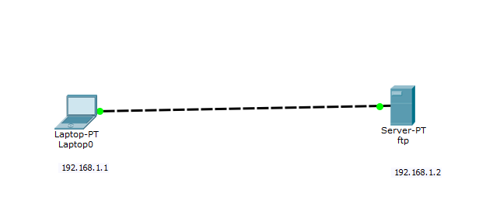

**Step 2** assign IP

ftp server

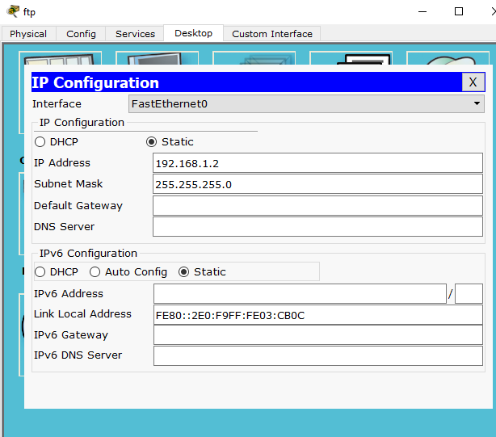

Pc

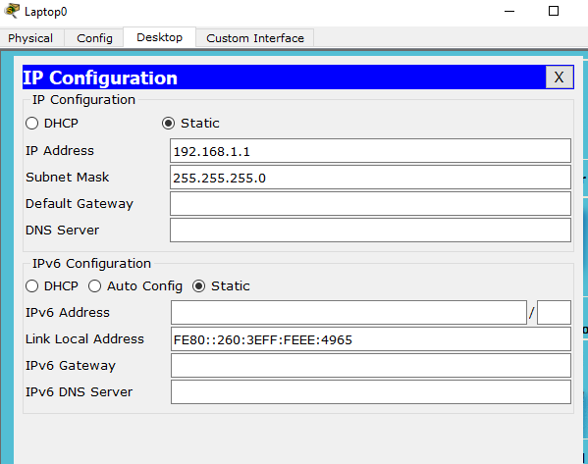

**Step 3**

1. go to pc
2. Go to desktop
3. Go to command prompt and connect ftp

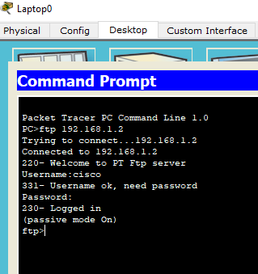

**Step 4**

1. Go to pc
2. Go to desktop
3. Go to file
4. Make txt file and name as myFile.txt

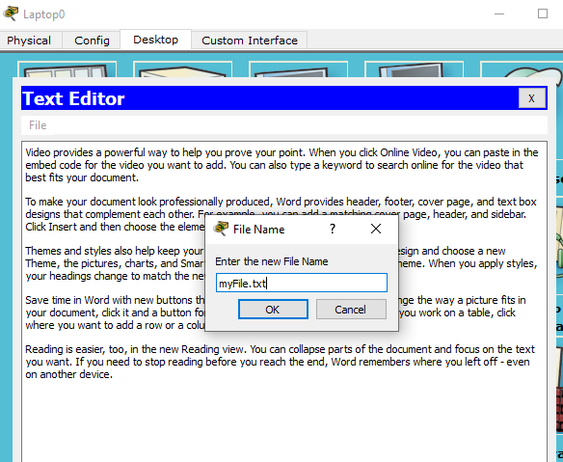

**Step 5**

Access it through command prompt

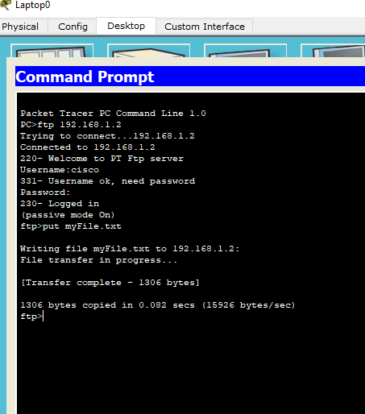

**Step 6**

1. Go to server
2. Services
3. And file user name and password

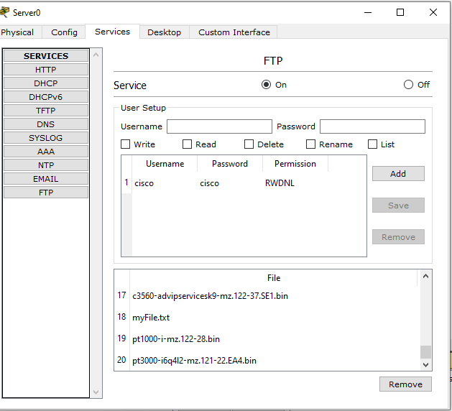

**Step 7**

Put myFile.txt to server

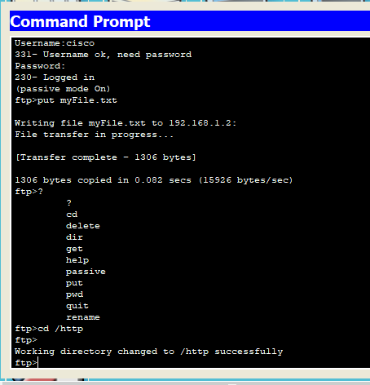

**Step 8**

Change to http

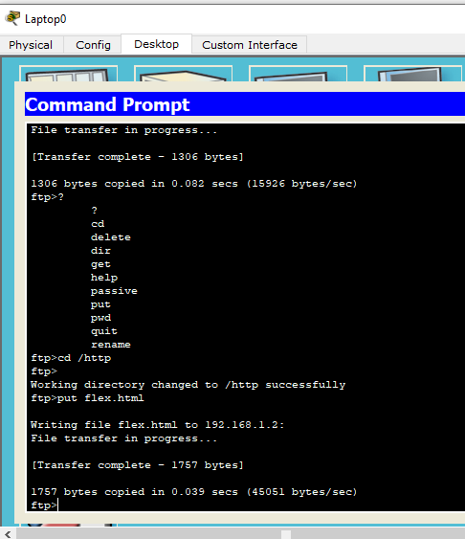

**Step 9** check working

